Exercise 1

10/10/2020

AIM:

To display month of the required year using python

Program:

import calendar

a=int(input())

b=int(input())

if(a<10000 and a>999 and b<13 and b>0):

print(calendar.month(a,b))

else:

print("Invalid Input")

Link: http://103.53.53.18/mod/vpl/forms/edit.php?id=229&userid=1787#

Output:

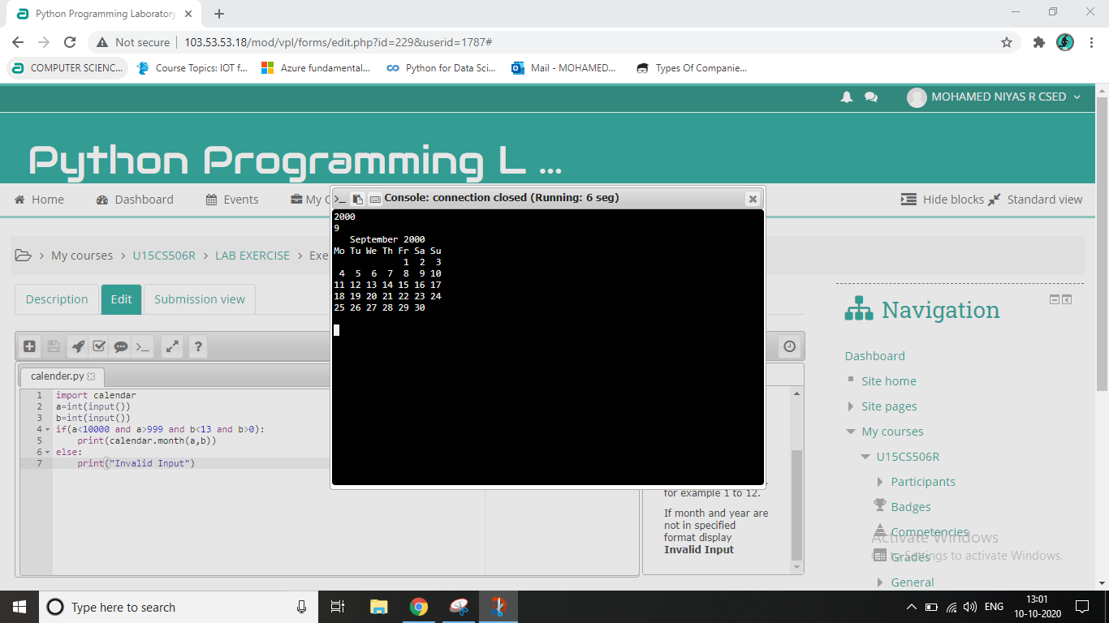

Result:

Month of the year was displayed correctly.